KFCCALMT9709 - EXAM PAPER - 200504 - MATHS P1 - TRIAL EXAM – TAYLOR

- 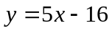
- 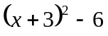 (a) 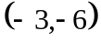 (b) 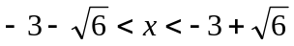
- (a) 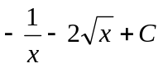 (b) 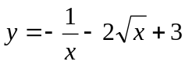
- (a) 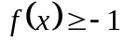 (b) one-one function when domain restricted. (c) 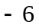 (d) 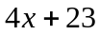
- (b) 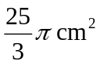 (c) 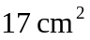
- (a) 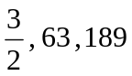 (b) 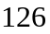
- , 7 ; 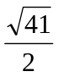
- (a) 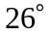 , 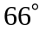 , 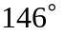
- (a) 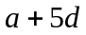 (c) 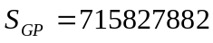 , 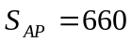
- (a) 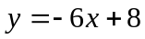 (c) 